Bahria University,

Karachi Campus



LAB EXPERIMENT NO.

03

LIST OF TASKS

|  |  |
| --- | --- |
| TASK NO | OBJECTIVE |
| 1 | 1. Calculate grade of each student 2. Calculate status of each student (Pass or Fail)   (3) Calculate number of students who have passed and failed   1. Calculate average percentage |
| 2 | 1. Top three games that are popular among teens. 2. Report five most downloaded applications in social media category. 3. How many applications have never been rated. 4. Report top paid application of each category. 5. Which are the top three categories famous among adults. 6. Report all applications of "google" |

Submitted On:

20-OCT-2023

(Date: DD/MM/YYYY)

**LAB 03 INTRODUCTION TO CSV FILES**

**DATA.CSV**

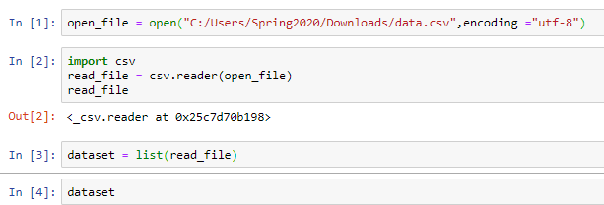

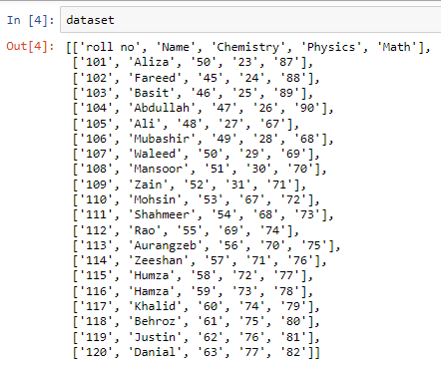

1. Calculate grade of each student
2. Calculate status of each student (Pass or Fail)

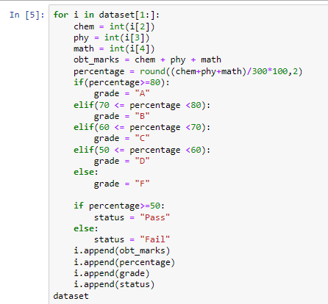

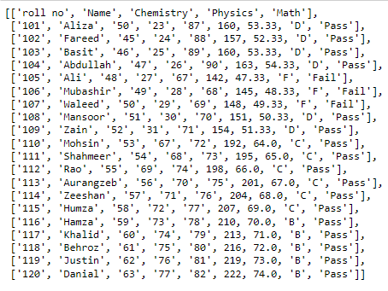

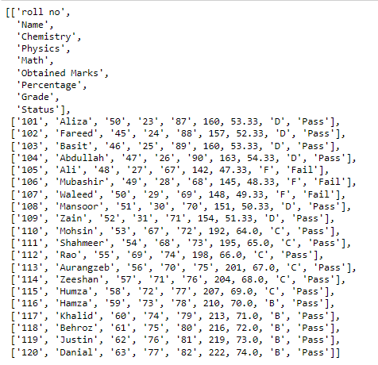

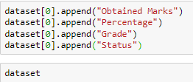

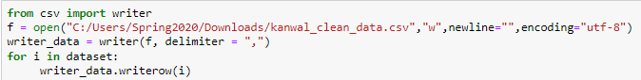

(3) Calculate number of students who have passed and failed

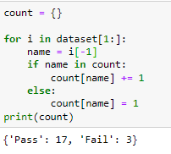

(4) Calculate average percentage

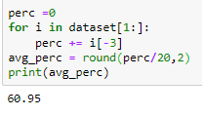

**APPLESTORE.CSV**

1. Top three games that are popular among teens.

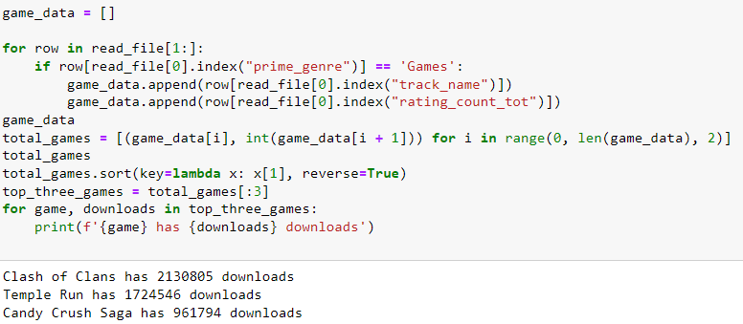

1. Report five most downloaded applications in social media category.

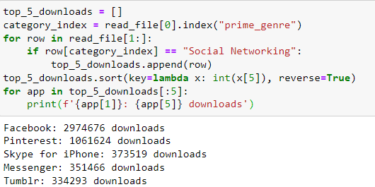

1. How many applications have never been rated.

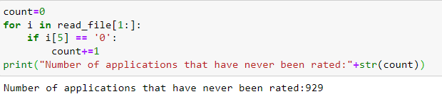

(4) Report top paid application of each category.

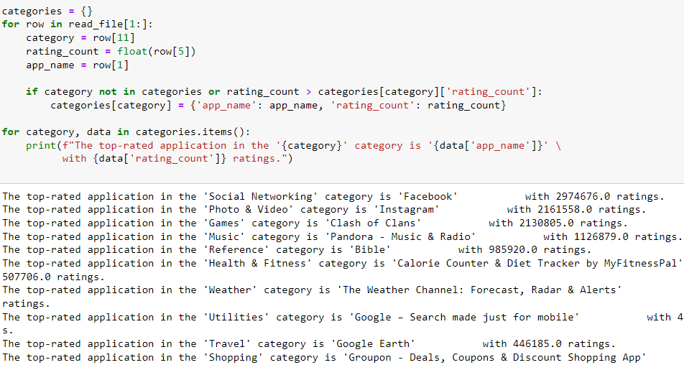

1. Which are the top three categories famous among adults.

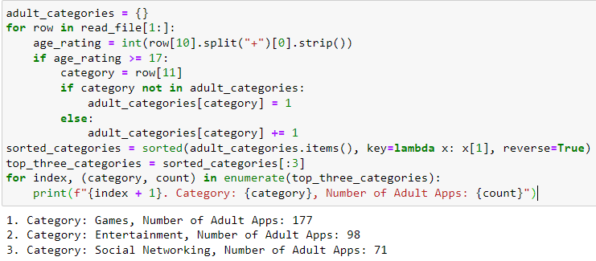

1. Report all the applications of a google

